Challenge-5

Marzuki Nooranas

2023-09-11

## Questions

#### Question-1: Local Variable Shadowing

Create an R function that defines a global variable called x with a value of 5. Inside the function, declare a local variable also named x with a value of 10. Print the value of x both inside and outside the function to demonstrate shadowing.

**Solutions:**

# Enter code here  
x <- 5   
  
shadowing <- function() {  
 x <- 10  
 print(paste("Inside the function, x is:", x))  
}  
shadowing()

## [1] "Inside the function, x is: 10"

print(paste("Outside the function, x is:", x))

## [1] "Outside the function, x is: 5"

#### Question-2: Modify Global Variable

Create an R function that takes an argument and adds it to a global variable called total. Call the function multiple times with different arguments to accumulate the values in total.

**Solutions:**

# Enter code here  
  
#this is to initiate the variable   
total <- 0  
  
add_total <- function(number) {  
 total <<- total + number  
 print(paste("total is now ", total))  
}  
  
add_total(5)

## [1] "total is now 5"

add_total(5)

## [1] "total is now 10"

add_total(5)

## [1] "total is now 15"

#### Question-3: Global and Local Interaction

Write an R program that includes a global variable total with an initial value of 100. Create a function that takes an argument, adds it to total, and returns the updated total. Demonstrate how this function interacts with the global variable.

**Solutions:**

# Enter code here  
  
  
total <- 100  
  
add_total <- function(number) {  
 total <<- total + number  
 return(total)  
}  
  
new_total <- add_total(10)  
sprintf ("The new total is %d", new_total)

## [1] "The new total is 110"

new_total <- add_total(20)  
sprintf ("The new total is %d", new_total)

## [1] "The new total is 130"

new_total <- add_total(30)  
sprintf ("The new total is %d", new_total)

## [1] "The new total is 160"

#### Question-4: Nested Functions

Define a function outer_function that declares a local variable x with a value of 5. Inside outer_function, define another function inner_function that prints the value of x. Call both functions to show how the inner function accesses the variable from the outer function’s scope.

**Solutions:**

# Enter code here  
  
outer_function <- function(){  
 x <- 5  
 inner_function <- function() {  
 sprintf ("The value of x is %d", x)  
 }  
 inner_function()  
}  
outer_function()

## [1] "The value of x is 5"

#### Question-5: Meme Generator Function

Create a function that takes a text input and generates a humorous meme with the text overlaid on an image of your choice. You can use the magick package for image manipulation. You can find more details about the commands offered by the package, with some examples of annotating images here: <https://cran.r-project.org/web/packages/magick/vignettes/intro.html>

**Solutions:**

# Enter code here  
library(magick)

## Linking to ImageMagick 6.9.12.93  
## Enabled features: cairo, fontconfig, freetype, heic, lcms, pango, raw, rsvg, webp  
## Disabled features: fftw, ghostscript, x11

create_meme <- function(image_path, meme_text) {  
 img <- image_read(image_path)  
   
 # add text  
 meme <- img %>%  
 image_annotate(text = meme_text,   
 gravity = 'south',   
 location = "+0+100",   
 size = 200,   
 font = "Impact",   
 strokecolor = "black",   
 color = "white")  
  
   
 return(meme)  
}  
  
create_meme("/Users/marzuki/Desktop/NM2207/NM2207/Week-5/meme.png", "Me after NM2207")

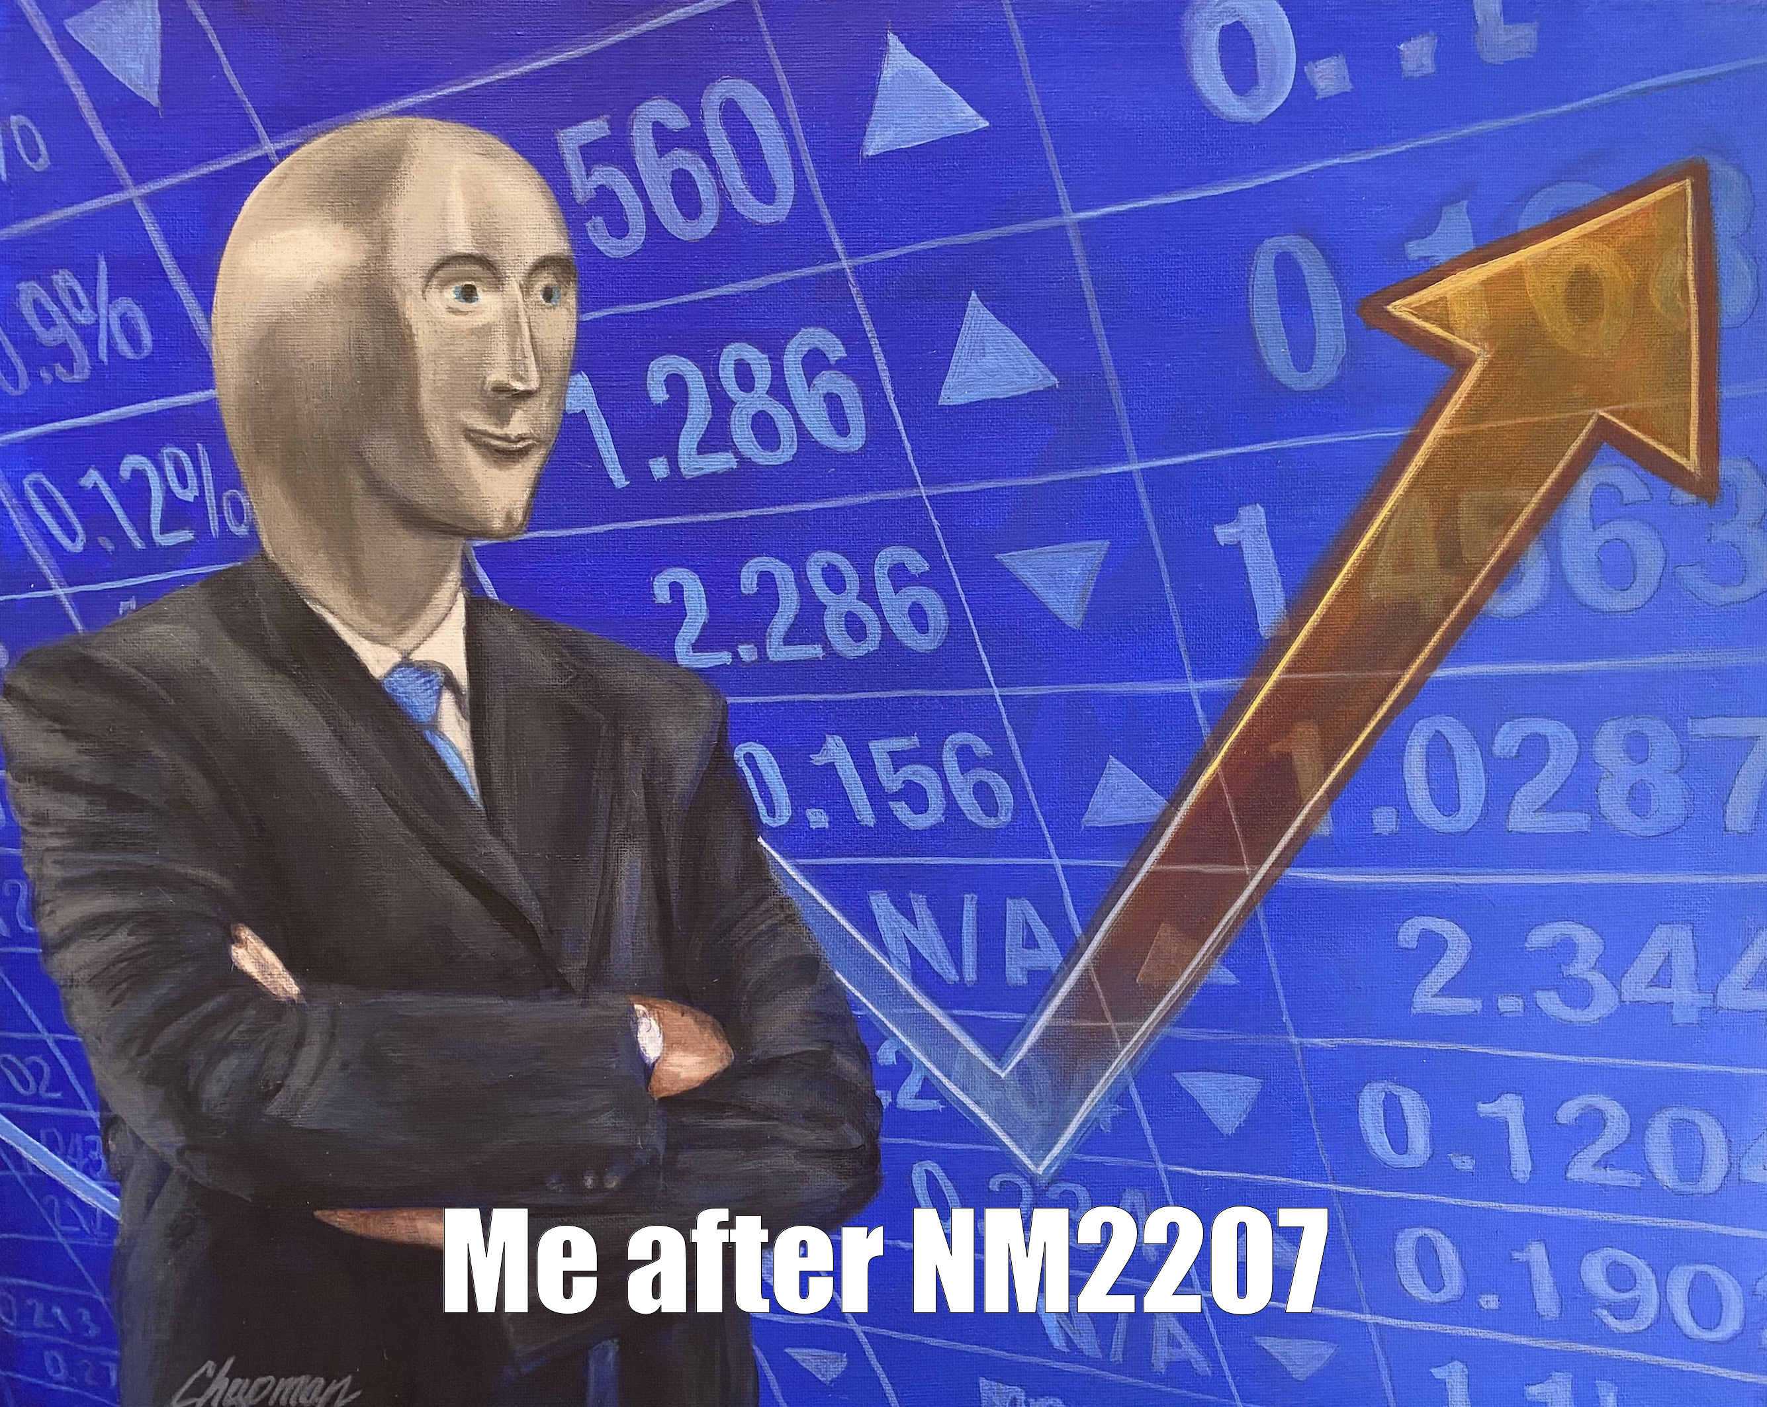

#### Question-6: Text Analysis Game

Develop a text analysis game in which the user inputs a sentence, and the R function provides statistics like the number of words, characters, and average word length. Reward the user with a “communication skill level” based on their input.

**Solutions:**

# Enter code here  
  
text_analysis_game <- function(sentence) {  
  
 cat("Hello everyone, time for the Text Analysis Game!\n")  
 cat("Analyzing the sentence:\n")  
   
 # number of words  
 word_count <- strsplit(sentence, " ")[[1]]  
 n_words <- length(word_count)  
   
 # number of char  
 n_chars <- nchar(sentence)  
   
 # average word length  
 word_lengths <- sapply(word_count, nchar)  
 avg_length <- mean(word_lengths)  
   
 # statistics  
 cat("\nHere are the results:\n")  
 cat("Number of words:", n_words, "\n")  
 cat("Number of characters:", n_chars, "\n")  
 cat("Average word length:", avg_length, "\n")  
   
 # Calculate a score   
 score <- (n_words * 2) + (n_chars / 10) - (avg_length * 3)  
   
 # calculate score i think  
 if (score < 20) {  
 skill_level <- "Room for improvement. Keep practicing!"  
 } else if (score >= 20 & score <= 50) {  
 skill_level <- "Not bad at all! You're doing great."  
 } else {  
 skill_level <- "Excellent! Your communication skills are top-notch."  
 }  
   
 # print  
 cat("Your score is:", score, "\n")  
 cat("Your communication skill level is:", skill_level, "\n")  
}  
  
  
text_analysis_game("This is an example of the sentence maybe I could try to calculate the score")

## Hello everyone, time for the Text Analysis Game!  
## Analyzing the sentence:  
##   
## Here are the results:  
## Number of words: 15   
## Number of characters: 75   
## Average word length: 4.066667   
## Your score is: 25.3   
## Your communication skill level is: Not bad at all! You're doing great.